WHY IS THERE A GAP?
After thirty years of inadequate indexing of the Medicare rebate, seven years of NO indexation plus the Medicare freeze for seven years and the costs of running a practice rising, the only way for a medical practice to remain viable with universal bulk billing is to compromise on quality resulting in short consultations, the risk of missed diagnoses, unnecessary test ordering, referrals and prescribing with extra flow on costs to the patient and reduced safety.
The doctors of this practice value quality of care which means some gap payments.
YOUR FEE DOES NOT JUST PAY FOR THE DOCTOR, IT PAYS FOR EVERYTHING YOU SEE
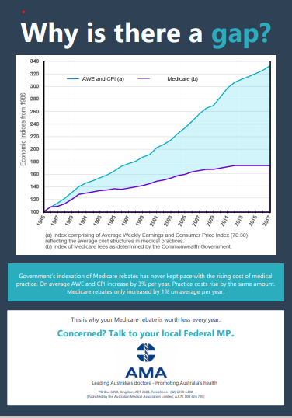
Reception, nursing, administration and cleaning staff, furniture, walls, paint, computers, phones, stethoscopes, otoscopes, dermatoscopes, blood pressure, ECG and lung function machines, pulse oximeters, defibrillator, oxygen, needles, syringes, dressings, surgical equipment, face masks, gloves, nebulisers, vaccine fridges with temperature monitoring and recording, examination couches, speculums, surgical lights, sheets, scales, liquid nitrogen, cryogenic flasks, disposable covers, printers, ear pieces, uninterrupted power supply, toilet paper, hand wash, hand sanitiser, tissues, ink , bins and liners, medications, local anaesthtics, sterilizer and more.
AND EVERYTHING YOU DON’T SEE
Training to keep GP’s and staff up to date, indemnity insurance, medical registration, professional college membership, rent, rates, electricity, insurances, internet, IT systems and support, software licenses, document and waste disposal, air conditioning, repairs and maintenance, sewerage pump out, water, accounting services, accreditation fees, etc

